Assembly Instruction Manual
Bottom of the robot (Sabir Mohammed)
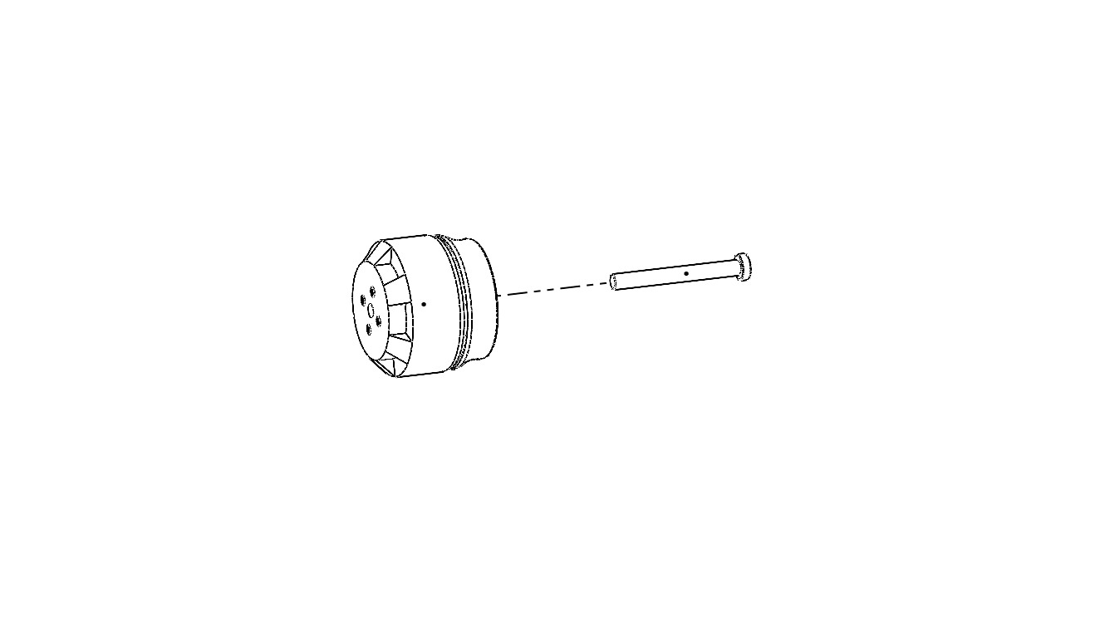
Step 1: Insert shaft into motor.

Step 2: Secure the motor by attaching it using screw from the back of the wheel center cap.
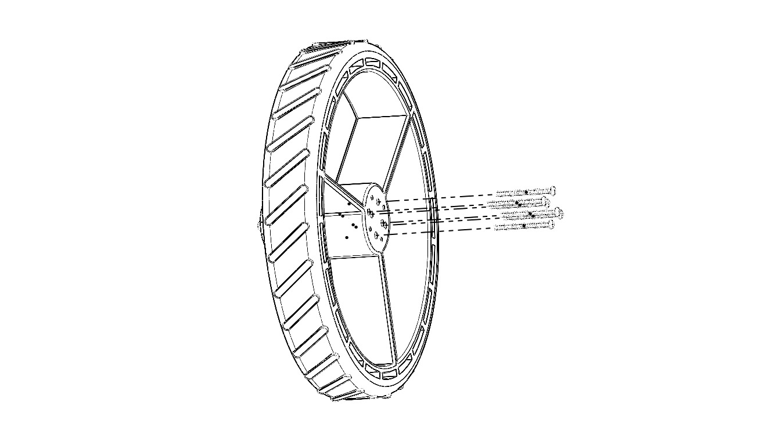

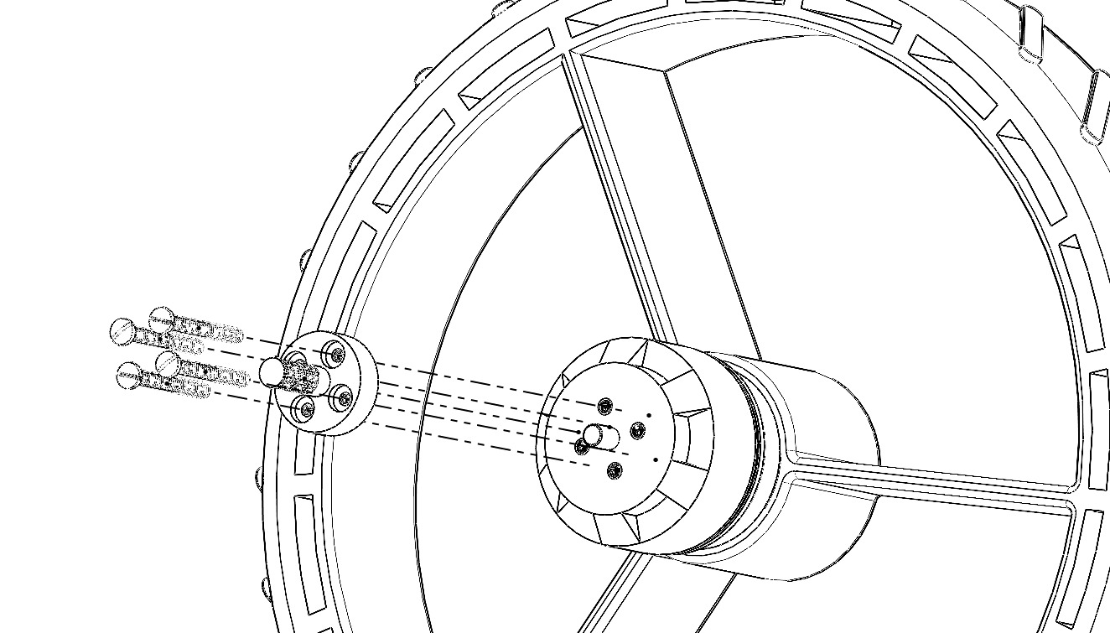
Step 3: Attach propeller adapter thread to the motor using screws.

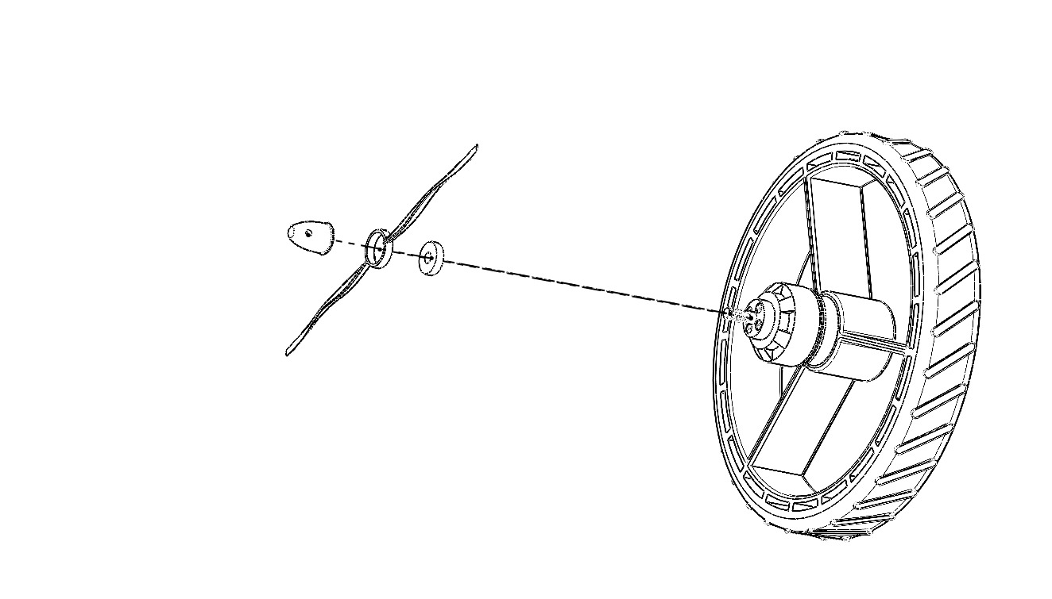
Step 4: Attach the spacer and propeller to the propeller adapter thread.

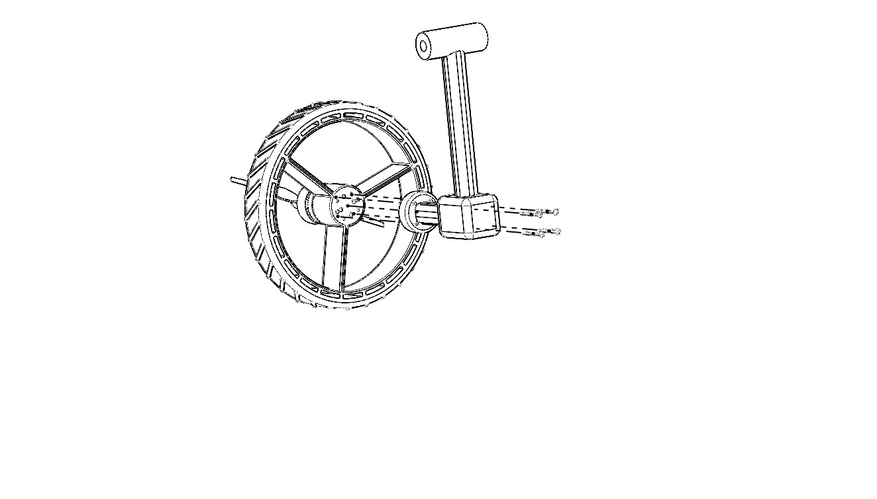
Step 5: Attach the leg of the robot to the center cap using screws as shown.

Step 6: Bring the leg joint close to the top of the robot leg and then slide the shaft through the hole. Finally, tighten it using nuts.
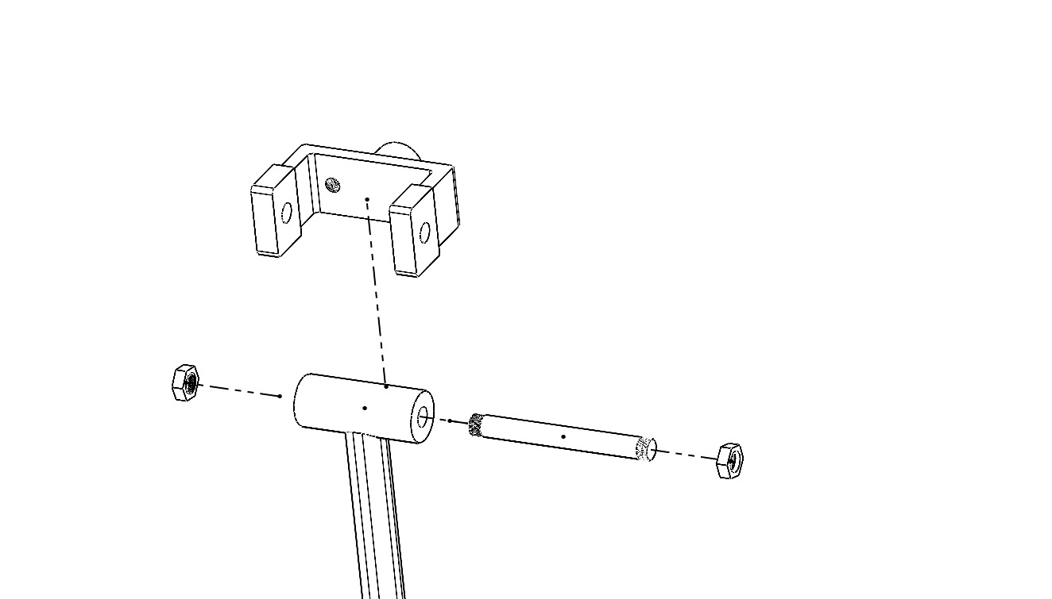

Final product:
